Muse Sleep Project

Purpose:
To learn about one's sleep, at home without formal sleep study in a sleep clinic.
It is known how normal sleep phases should look like. This software should enable to compare one's sleep with normal, healthy sleep. This can lead to understanding how one's daily behavior, eating habits, medication etc. affects sleep.

High level project outline
Collect EEG data from the band and store in a file (format TBD)

Pass data to EEG signal processing software:
- filter noise
- derive alpha, beta, delta waves
- interpret as phases of sleep : write to file, sleep phases vs. time
- graphically present phases of sleep data

Sample Graph:
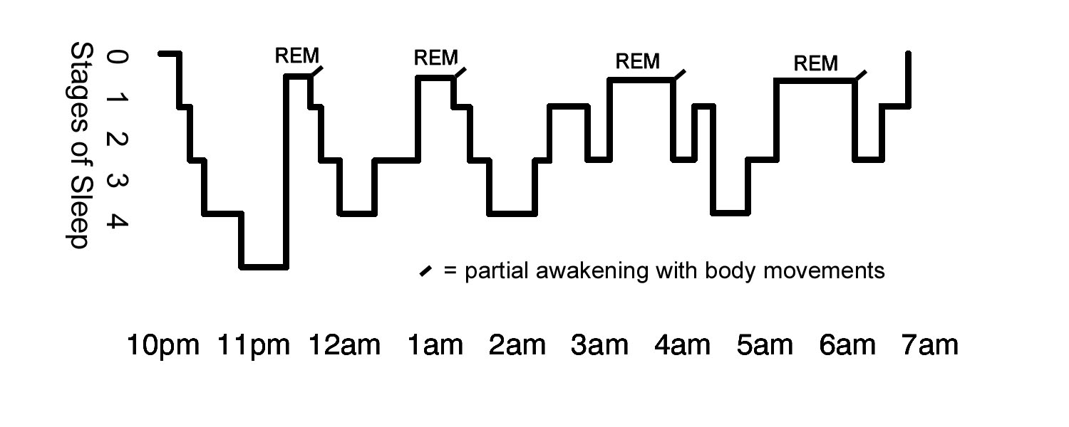
Link to more graphs:

https://www.google.com/search?q=sleep+phases&biw=1342&bih=865&tbm=isch&imgil=jYcO8YG5xizF4M%253A%253BhNiNxXQq77WTgM%253Bhttp%25253A%25252F%25252Fwww.intropsych.com%25252Fch03_states%25252Fstages_of_sleep.html&source=iu&pf=m&fir=jYcO8YG5xizF4M%253A

Stages of Sleep
Usually sleepers pass through five stages: 1, 2, 3, 4 and REM (rapid eye movement) sleep. These stages progress cyclically from 1 through REM then begin again with stage 1. A complete sleep cycle takes an average of 90 to 110 minutes. The first sleep cycles each night have relatively short REM sleeps and long periods of deep sleep but later in the night, REM periods lengthen and deep sleep time decreases.
Stage 1 is light sleep where you drift in and out of sleep and can be awakened easily. In this stage, the eyes move slowly and muscle activity slows. During this stage, many people experience sudden muscle contractions preceded by a sensation of falling.
In stage 2, eye movement stops and brain waves become slower with only an occasional burst of rapid brain waves. When a person enters stage 3, extremely slow brain waves called delta waves are interspersed with smaller, faster waves. In stage 4, the brain produces delta waves almost exclusively. Stages 3 and 4 are referred to as deep sleep or delta sleep, and it is very difficult to wake someone from them. In deep sleep, there is no eye movement or muscle activity. This is when some children experience bedwetting, sleepwalking or night terrors. In 2008 the sleep profession in the US eliminated the use of stage 4. Stages 3 and 4 are now considered stage 3.
Slow wave sleep comes mostly in the first half of the night, REM in the second half. Waking may occur after REM. If the waking period is long enough, the person may remember it the next morning. Short awakenings may disappear with amnesia.
In the REM period, breathing becomes more rapid, irregular and shallow, eyes jerk rapidly and limb muscles are temporarily paralyzed. Brain waves during this stage increase to levels experienced when a person is awake. Also, heart rate increases, blood pressure rises, males develop erections and the body loses some of the ability to regulate its temperature. This is the time when most dreams occur, and, if awoken during REM sleep, a person can remember the dreams. Most people experience three to five intervals of REM sleep each night.
Infants spend almost 50% of their time in REM sleep. Adults spend nearly half of sleep time in stage 2, about 20% in REM and the other 30% is divided between the other three stages. Older adults spend progressively less time in REM sleep.
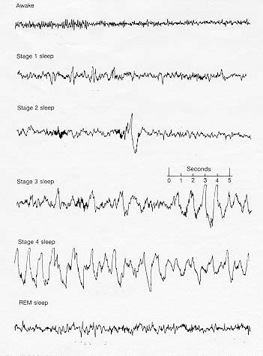
As sleep research is still a relatively young field, scientists did not discover REM sleep until 1953 when new machines were developed to monitor brain activity. Before this discovery it was believed that most brain activity ceased during sleep. Since then, scientists have also disproved the idea that deprivation of REM sleep can lead to insanity and have found that lack of REM sleep can alleviate clinical depression although they do not know why. Recent theories link REM sleep to learning and memory.
Stage | Frequency (Hz) | Amplitude (micro Volts) | Waveform type
awake | 15-50 | <50
pre-sleep | 8-12 | 50 | alpha rhthym
1 | 4-8 | 50-100 | theta
2 | 4-15 | 50-150 | splindle waves
3 | 2-4 | 100-150 | spindle waves and slow waves
4 | 0.5-2 | 100-200 | slow waves and delta waves
REM | 15-30 | <50

The brain waveform during REM has low amplitudes and high frequencies, just like the waking state. Early researchers actually called it "paradoxial sleep".
The American Academy of Sleep Medicine has floated use of the term "Stage R" for REM sleep, but this new terminology has not caught on.
Stages
Waking | REM Sleep | NREM Sleep
Stage 0 | Stage R
  Light Sleep | Deep Sleep
    Stage 1 | Stage 2
    Stage 3 | Stage 4
Eyes open, responsive to external stimuli, can hold intelligible conversation | Brain waves similar to waking. Most vivid dreams happen in this stage. Body does not move.
  Transition between waking and sleep. If awakened, person will claim was never asleep. | Main body of light sleep. Memory consolidation. Synaptic pruning. | Slow waves on EEG readings. | Slow waves on EEG readings.
16 to 18 hours per day | 90 to 120 min/night | 4 to 7 hours per night
Ref. http://www.sleepdex.org/stages.htm

